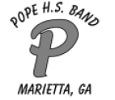
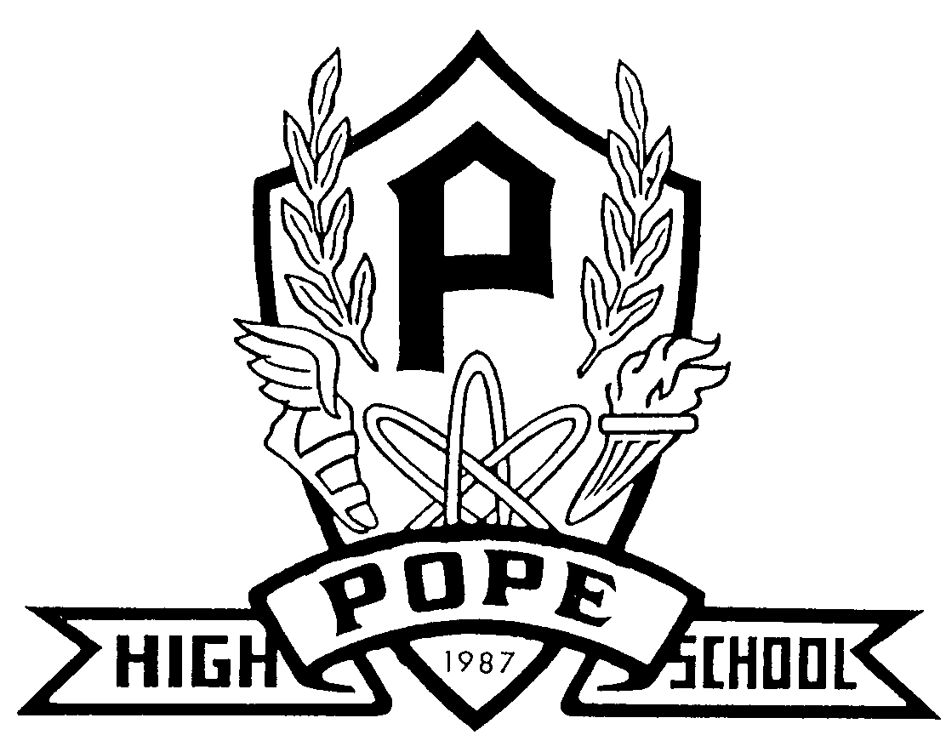
Alan C. Pope High School Band
3001 Hembree Road
Marietta, Georgia 30062
770-578-7909 – phone
Gary Gribble, Director of Bands Josh Rudolph, Assoc. Director of Bands

Pope High School Marching Band

WCU – Tournament of Champions

Saturday, October 21, 2017

7:30 AM Band room opens
7:45 Call time
7:55 Load Buses
8:00 Depart Pope
11:30 Arrive at Ryan’s Steakhouse for lunch (provided)
374 Wal-Mart Plaza
Sylva, NC
12:30 Depart Lunch
1:45 Warm-up
2:45 POPE PERFORMS
4:20 Prelims Awards
5:00 Dinner (provided)
6:45 Finals Begin
10:20 Finals Awards
11:00 Depart Western Carolina University
2:15 AM Arrive at Pope HS

In the event we are selected as a finalist band we will send out a Remind message with our performance time. Finalist performance times are determined by draw at the Directors’ meeting immediately following the preliminary awards ceremony.

All students will need to wear their BALANCE shirt underneath their uniform on Saturday, so please wear a light colored t-shirt underneath your uniform for the football game the night before the contest.

Both lunch and dinner will be provided

We would like to encourage all parents, family, and friends of the Pope Band to sit together and cheer loudly. The kids have worked hard and they always perform better for a loud and supportive crowd!

***ALL STUDENTS ARE EXPECTED TO RIDE THE BUS TO AND FROM WESTERN CAROLINA UNIVERSITY***

