http://www.elkharttruth.com/news/schools/2014/10/20/Elkhart-Central-marching-band-super-involved-high-school-marching-band-students-are-learning-time-management.html

At Elkhart Central High School, super-involved marching band students are learning time management
Many members of Elkhart Central’s Blazer Brigade spend dozens of hours participating in other extracurricular activities, working part-time jobs and volunteering — even during the busy marching band season.
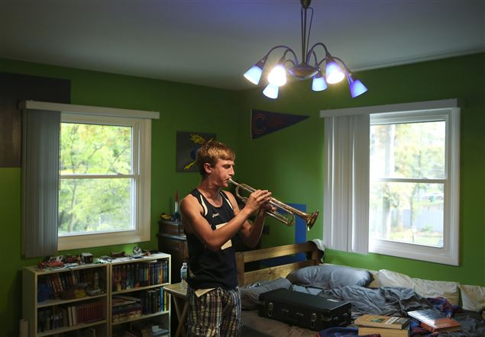
Central sophomore Ian Fahrenkrog, 16, plays his trumpet after a portrait with The Elkhart Truth in his room on Tuesday, Oct. 14, 2014, Elkhart. Fahrenkrog started playing trumpet in sixth grade but switch the french horn and plays the mellophone in Central's marching band. In addition to his involvement in the Blazer Brigade, he ran cross country, takes four AP classes and takes part in many other activities. (Nick Gonzales/The Elkhart Truth)
Central drum major Nick Iavagnilio spends 20-plus hours every week with the marching band during the season, but that isn't even the biggest pull on his time.
He’s also involved in his church’s youth group, the band’s leadership team, pit orchestra, four AP classes, serving as president of the National Honor Society and a group leader in Future Problem Solvers, and he buses tables on the weekends at Michael’s Italian Restaurant.
As crazy as that sounds, Iavagnilio isn't alone with his jam-packed schedule.
Many of Central’s band students are super-involved in other activities, according to band director Dan Burton.
“We have a lot of kids that are very committed,” he said. “I think kids get a bum rap, nowadays, for being lazy…but our kids are active and they are good leaders within the group. I think the perception that kids don’t work as hard as they used to, I think that’s not true.”
And although the band’s competition season officially came to an end Saturday, Oct. 18, when the band didn’t qualify for the ISSMA semistate contest, the students still put in plenty of work, over several months, to produce the best show possible.
Burton surveyed the band students earlier this year about their other extracurricular activities and found they are representing the school in 16 different sports and 35 different clubs or groups — plus other activities not associated with the school at all.
Many students also work part-time jobs and volunteer.
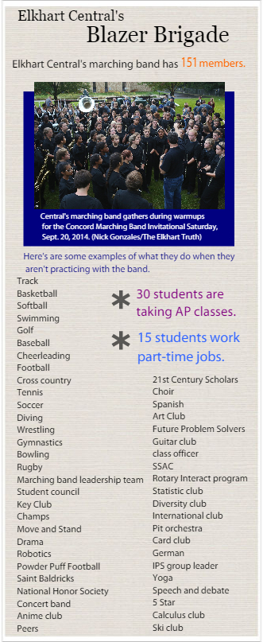
“It’s challenging for the staff but it is good for the kids,” Burton said. “The kids need to have a lot of different experiences in their lives. We are part of their total education, but it is not all-encompassing.”
Ian Fahrenkrog, a sophomore, said band is his top priority even though he’s also taking AP classes, involved in cross country, diving, track, robotic club and multiple other activities.
“I like the atmosphere of (marching band) and doing the shows is great,” he said. “It’s definitely worthwhile.”
Still, Burton said he and other staffers keep a close eye on students to make sure they’re not getting burned out.
“You can usually tell when they start getting really stressed,” he said. “There are times when we've sat kids down and said, you know, you need to go to whatever activity today instead of band rehearsal, because you can tell that is something they need to do to help them feel better.”
School staffers communicate with each other and work together to figure out what to do when students have to be in two places at the same time, he said.
Working with everyone’s schedule isn't always easy, but it is doable.
And helping students learn time management is one of the big lessons students learn through marching band, according to Burton.
“Band is just a vehicle to teach the kids what they need to know for life,” he said. “And it’s probably one of the greatest vehicles. When they come in, they learn how to work to create success.”
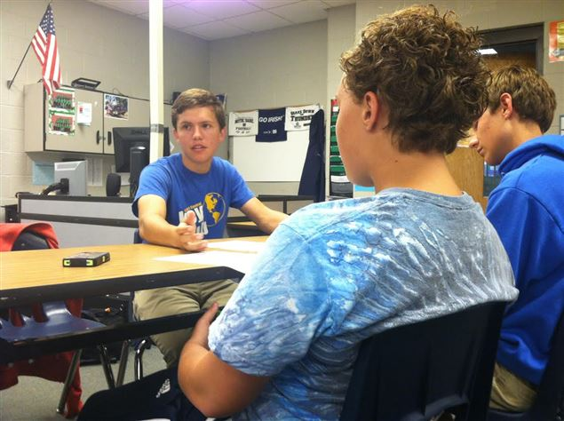
Central senior Nick Iavagnilio makes a point during a Future Problem Solvers meeting after school Wednesday, Oct. 15, 2014. Iavagnilio is also a drum major for Central's marching band along with the two other students pictured, McKenzie Beers and Ian Fahrenkrog. Many of marching band students are also involved in other activities. (Lydia Sheaks/The Elkhart Truth)

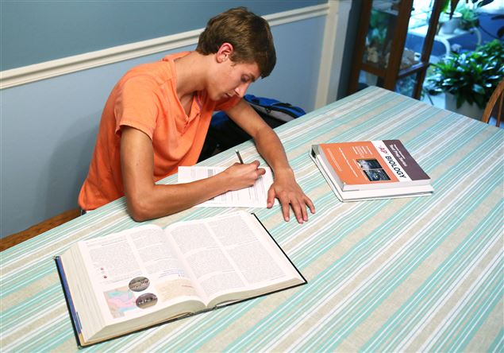
Central sophomore Ian Fahrenkrog, 16, does his advanced placement biology homework on Tuesday, Oct. 14, 2014, in his Elkhart home. Fahrenkrog stays busy with four AP classes, marching band, cross country, which just finished, student council, Future Problem Solvers club, robotics team and many more. (Nick Gonzales/The Elkhart Truth)

